Create Your First Amazon EC2 Instance (Windows)

STEP-1 : First open the AWS console home page.

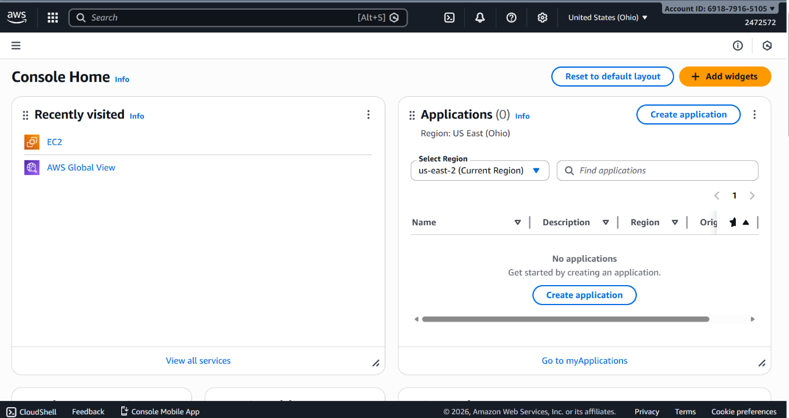

STEP-2: Next, click on the Launch Instance button to launch the instance.
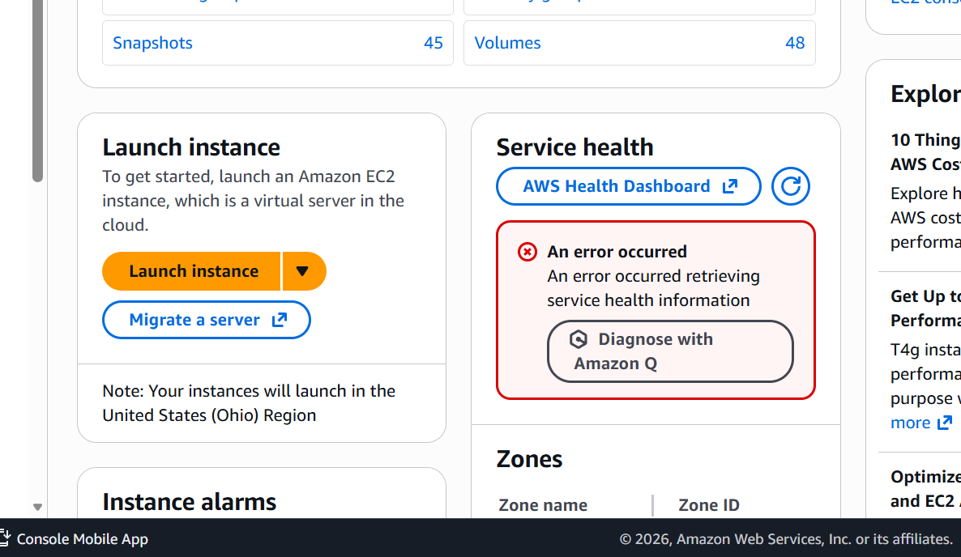

STEP-3: Now we need to select the Microsoft Windows Server for the Software Image (AMI)
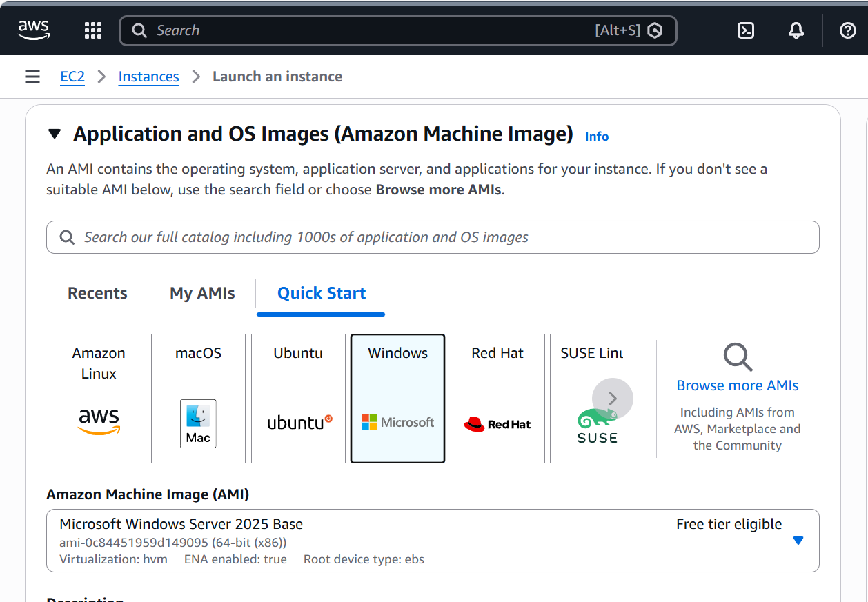

And, select the key-pair name then click on the Launch Instance.
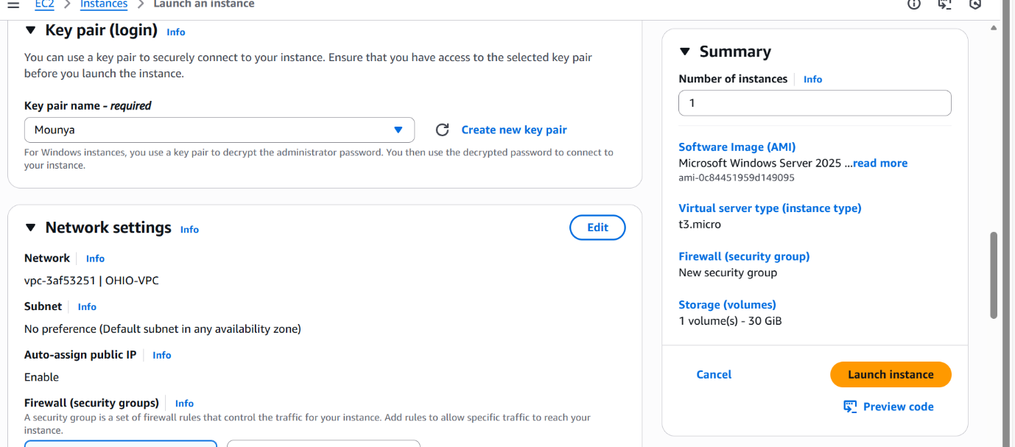

STEP-4: Now, it will redirect to Instances Page, where u need to select the Connect to Instance, and click on it.
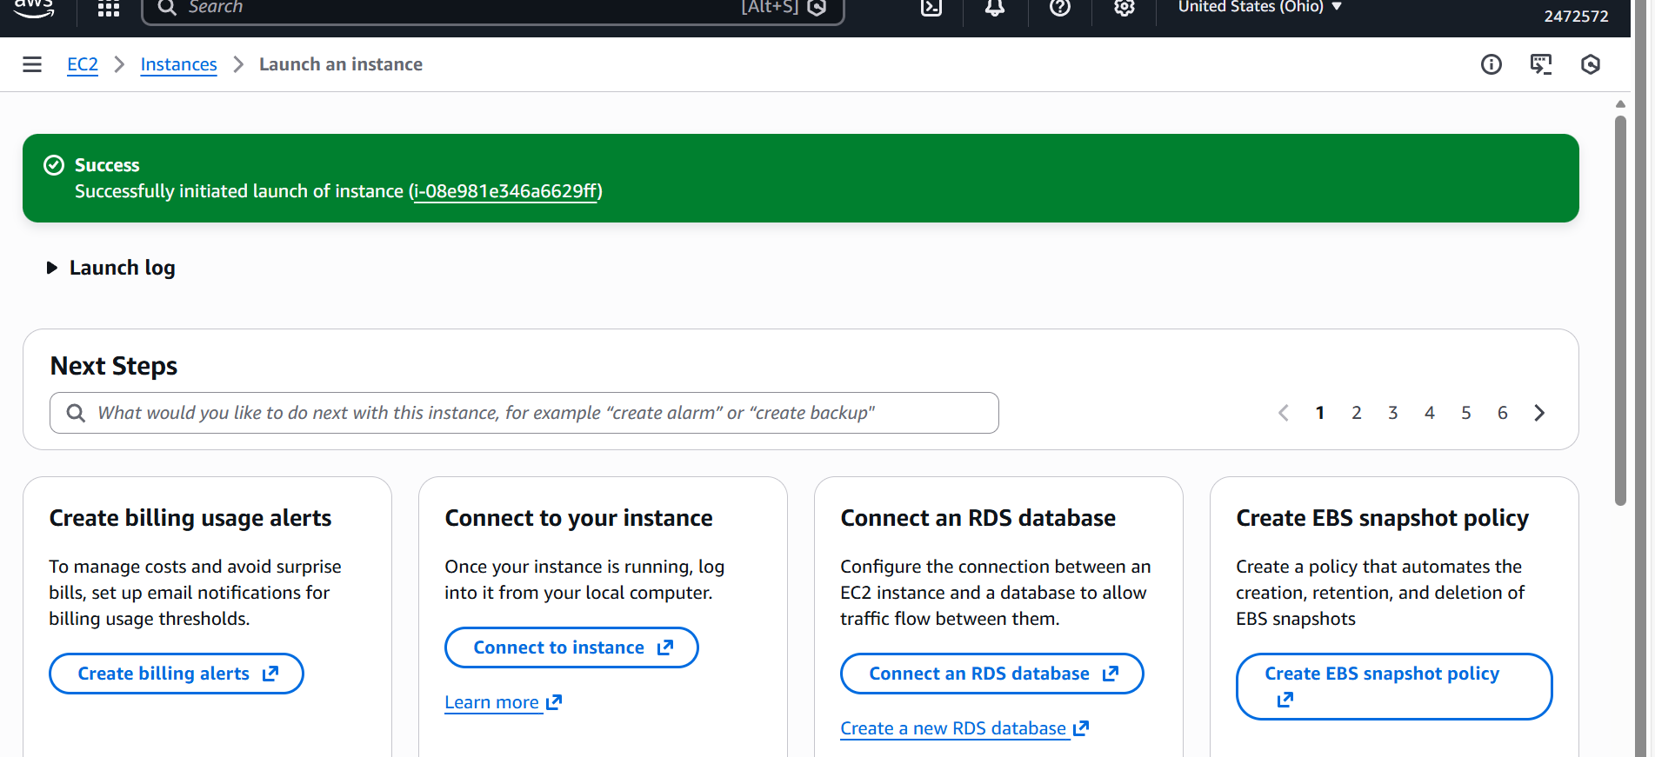

STEP-5: And it will redirect us to the page where we connect to an instance using the browser-based client i.e. RDP Client and click on it.

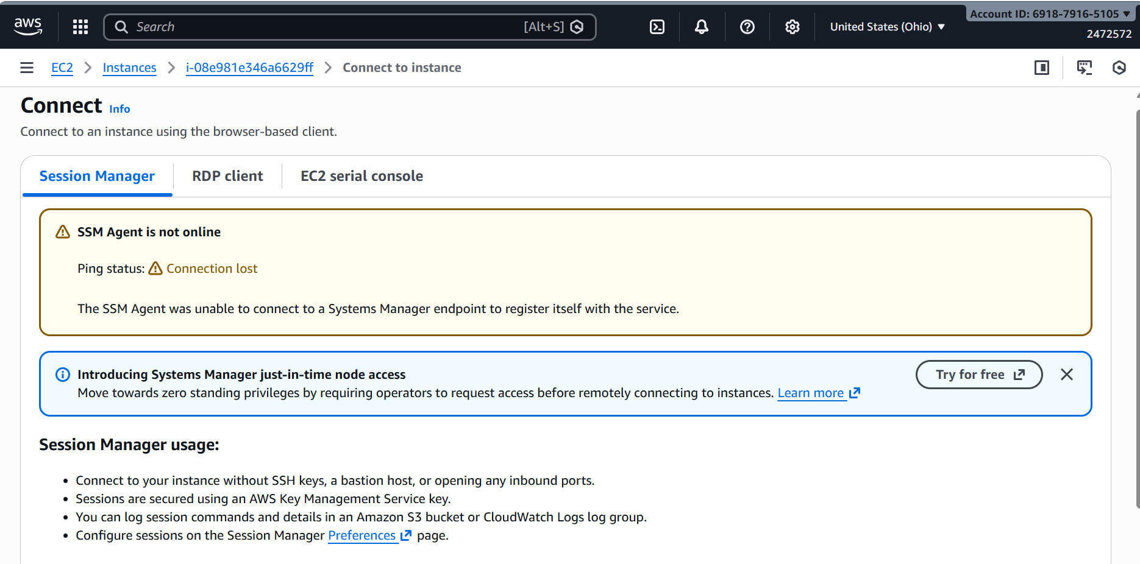

STEP-6: After connecting with RDA client this is the interface where we need to click to get a password decrypt
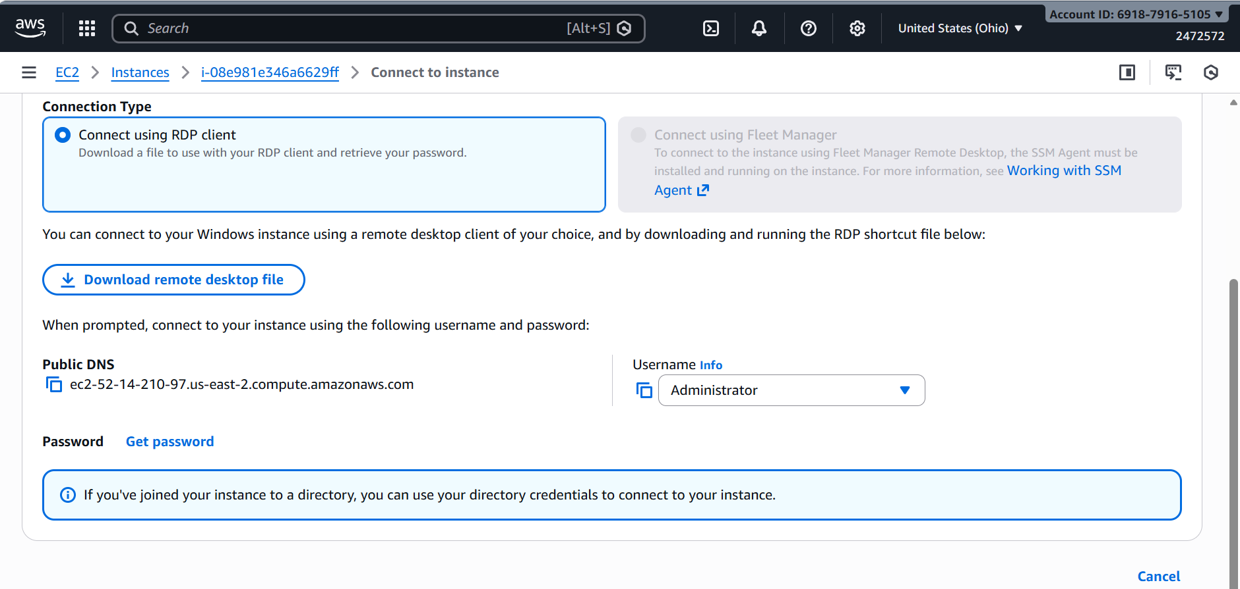

STEP-7: After getting the password then click on the Download remote desktop file.
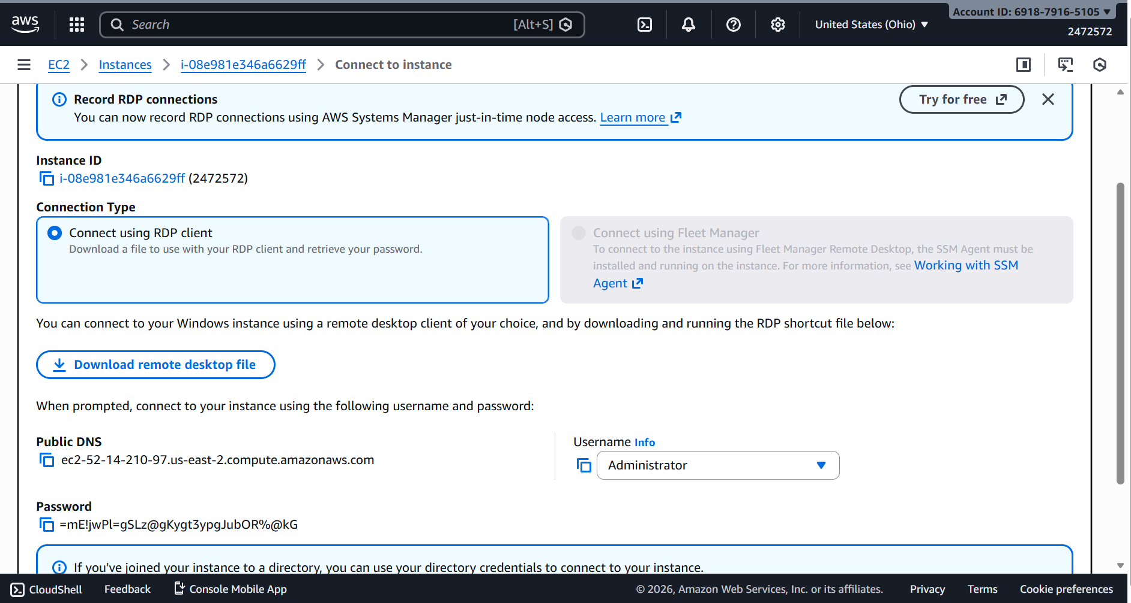

STEP-8: After downloading the file , open it and there will be a pop-up which asks for remote connection then click on the Connect button .
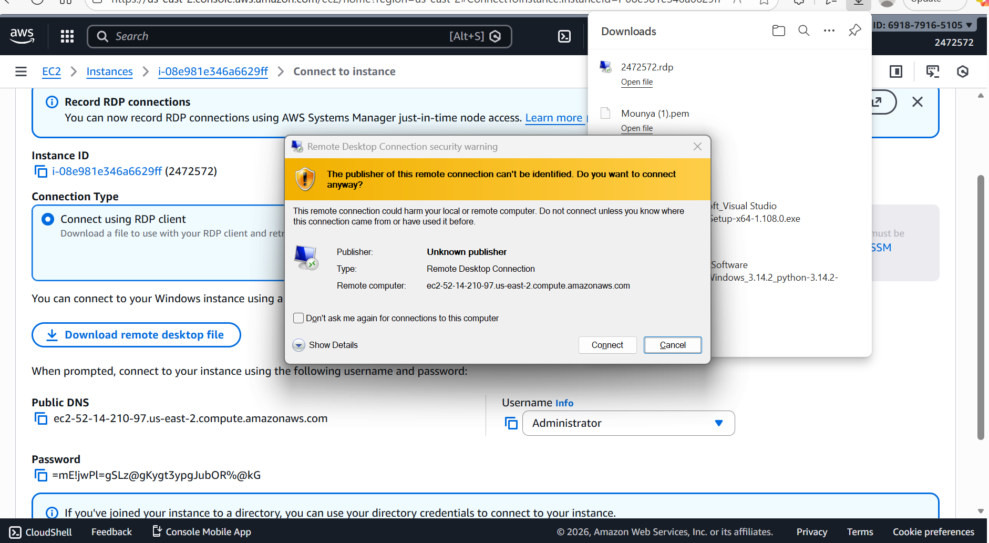

STEP-9: After clicking on the connect button, it asks for credentials which is used for connection, and enter the password and click ok

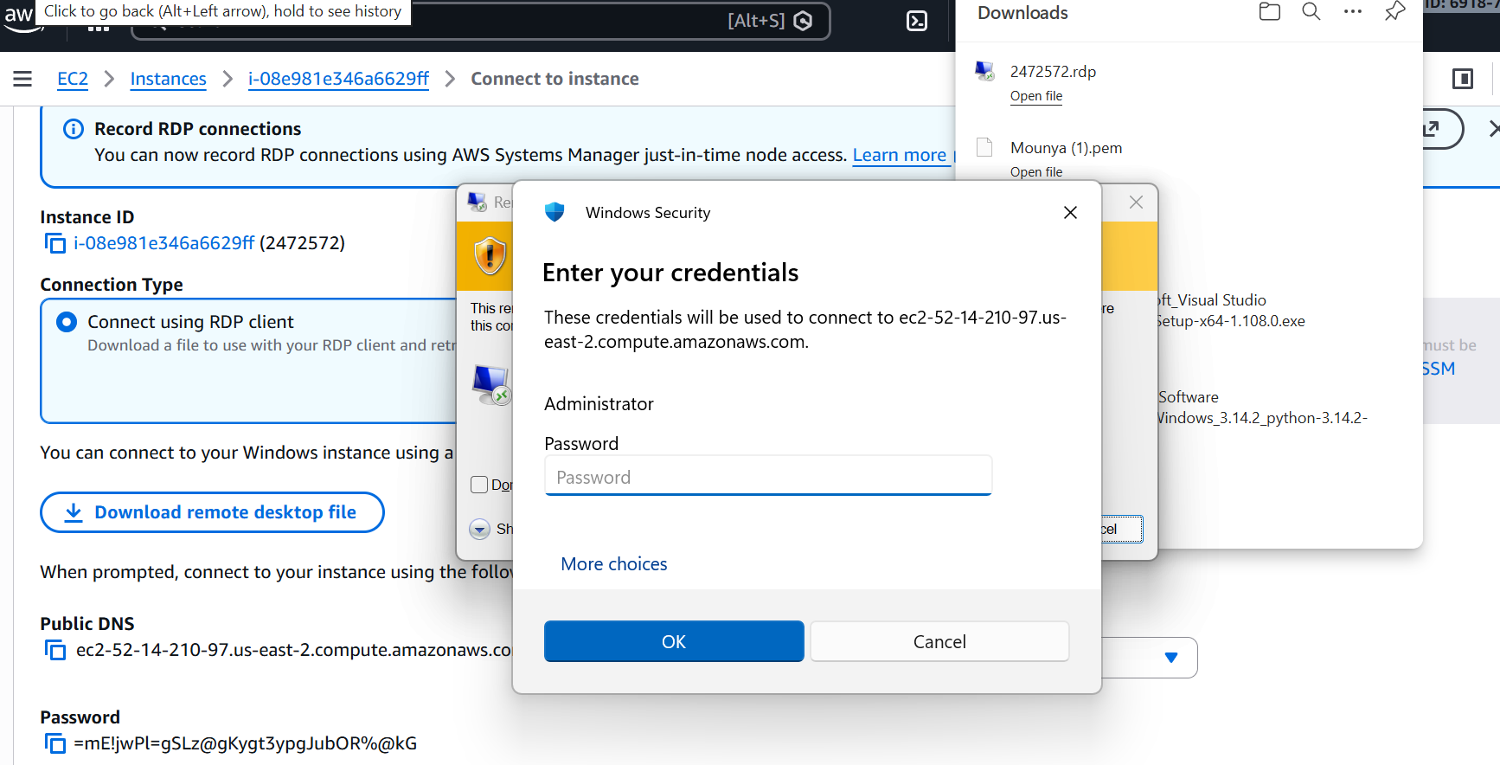

STEP-10:
